Big Data Analytics Notes

1. Fundamentals of Big Data
- Introduction to Big Data
- Characteristics of Big Data (Volume, Velocity, Variety, etc.)
- Google File System (P03 The Google File System.pdf)
- MapReduce Basics (P04 MapReduce - Simplified Data Processing...)
- Bigtable (P05 Bigtable - A Distributed Storage System...

2. Hadoop Ecosystem
- Apache Hadoop Architecture
- HDFS (Hadoop Distributed File System)
- MapReduce Programming
- YARN (Yet Another Resource Negotiator)
- Hadoop Components (08 Big Data Analytics with Apache Hadoop.pptx)
- Programming Hadoop with Pig, R, and Spark (09 Programming Hadoop...)
- Lecture Notes Summary (Lecture.docx)

3. Apache Spark
- Introduction to Spark
- RDDs (Resilient Distributed Datasets) (P07 RDDs...)
- Spark Architecture (P06 Spark - Cluster Computing...)
- Spark Programming Model
- MLlib – Machine Learning in Spark (BigData_Spark_MlLib_new1.pdf)
- Deep Learning with Spark (DeepLearn_Spark_Part1.pdf & Part2.pdf)

4. NoSQL Databases
- Introduction to NoSQL
- HBase
- Hive
- Cassandra

5. Graph Processing in Big Data
- Introduction to Graph Databases (Graph Databases.pdf)
- Apache Giraph (Giraph - Introduction...)
- Pregel and its Variants (Pregel.pdf, Pregel2.pdf, Pregel - A System...)
- Spark GraphX (Spark GraphX Tutorial & Tutorial2.pdf)
- Titan Graph DB (Titan Big Graph Data.pdf)

6. Real-Time Data Streaming
- Apache Kafka (Kafka.pdf)
7. Machine Learning on Big Data
- Apache Mahout (Bigdata_Mahout_ML_all Notes.pdf)
- MLlib (already covered under Spark)

Fundamentals of Big Data

1. Introduction to Big Data
Definition:
Big Data refers to extremely large datasets that are complex, grow rapidly, and cannot be processed using traditional data processing tools. These datasets come from various sources such as social media, sensors, transactions, logs, and more.
Purpose:
- Extract value and insight from data.
- Make data-driven decisions.
- Support real-time analytics.
Examples:
- Facebook generates 4 petabytes of data per day.
- Retailers analyse customer behaviour patterns from clickstream data.

2. Characteristics of Big Data (The 5 Vs)

Characteristic | Description
Volume | Refers to the sheer amount of data (TBs, PBs). Example: Logs, video, sensor data.
Velocity | The speed at which data is generated and processed. Example: Twitter feeds, stock trades.
Variety | Different types of data (structured, unstructured, semi-structured).
Veracity | Trustworthiness or accuracy of data.
Value | The potential insights that can be drawn to drive business outcomes.

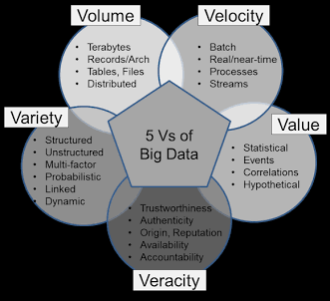

3. Google File System (GFS)
📄 Source: P03 The Google File System.pdf
Overview:
GFS is a scalable distributed file system developed by Google to handle large data processing workloads across thousands of machines.
Key Features:
- Chunk-based storage: Files are divided into 64MB chunks stored across machines.
- Master-slave architecture: One master server keeps metadata; multiple chunkservers store actual data.
- Fault tolerance: Replication (default: 3 copies) across machines ensures data reliability.
- Optimized for large files: GFS is not efficient for small files or frequent writes.

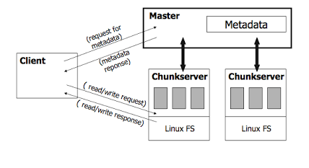

4. MapReduce Basics
📄 Source: P04 MapReduce - Simplified Data Processing on Large Clusters.pdf
Definition:
MapReduce is a programming model for processing and generating big data sets with a parallel, distributed algorithm on a cluster.
Workflow:
- Map Phase: Takes input and converts it into key-value pairs.
- Shuffle Phase: System redistributes data based on keys.
- Reduce Phase: Merges values with the same key.
Example: Word Count
- Map: ('Hello world') → [('Hello', 1), ('world', 1)]
- Reduce: [('Hello', 1), ('Hello', 1)] → ('Hello', 2)
Advantages:
- Scalable and parallel.
- Fault-tolerant.
- Suitable for large data.
Diagram:
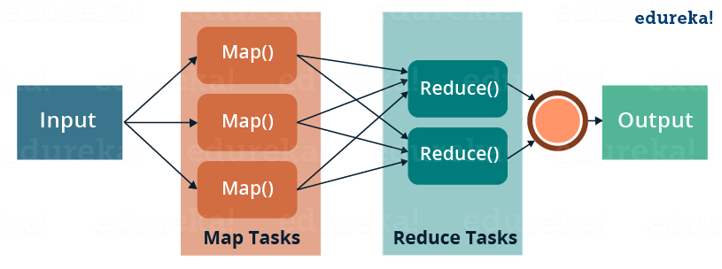

5. Bigtable
📄 Source: P05 Bigtable - A Distributed Storage System for Structured Data.pdf
Overview:
Bigtable is a high-performance, distributed storage system developed by Google to store structured data.
Key Concepts:
- Table-based: Data is stored in tables with rows and columns, similar to RDBMS but without a fixed schema.
- Sparse: Stores only non-empty cells; efficient storage.
- Column families: Columns are grouped and configured together.
Data Model:
sql
Row Key | Timestamp | ColumnFamily:Column | Value
------------|-----------|---------------------|------
user123 | 2023-12-01| profile:name | Alice
user123 | 2023-12-01| profile:email | alice@example.com
Applications:
- Google Search Index.
- Google Maps.
- Analytics platforms.
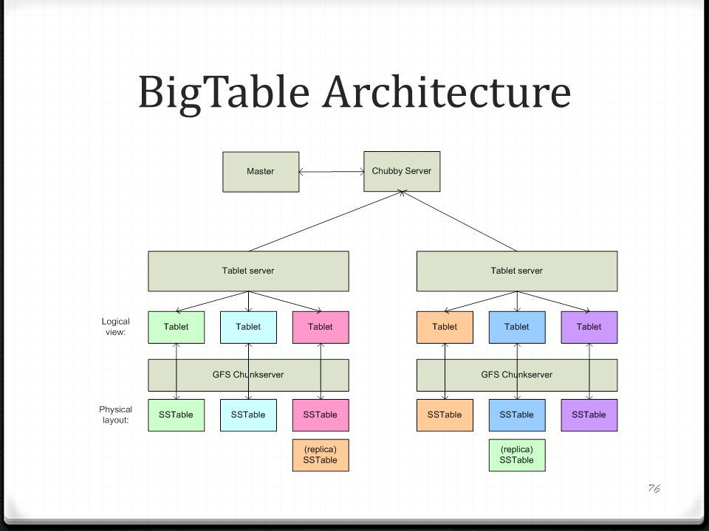

Hadoop Ecosystem

1. Apache Hadoop Architecture
Definition:
Apache Hadoop is an open-source framework designed to store and process large datasets across clusters of commodity hardware using a simple programming model.
Key Components:
- HDFS – Hadoop Distributed File System (Storage)
- MapReduce – Data processing engine
- YARN – Resource manager
- Common – Java libraries and utilities
High-Level Architecture:

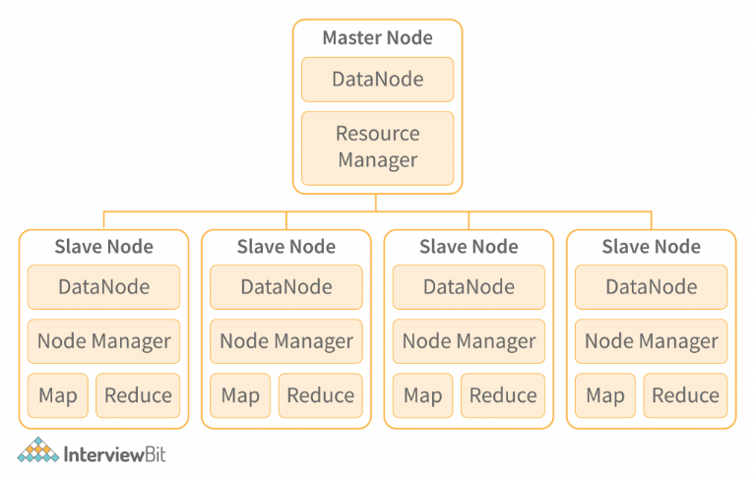

2. HDFS (Hadoop Distributed File System)
Purpose:
Designed to reliably store large files across multiple machines in a cluster.
Key Concepts:
- Block Storage: Files split into blocks (default 128MB or 256MB).
- Replication: Default 3 copies across different nodes for fault tolerance.
- NameNode: Master node that stores metadata.
- DataNode: Slave nodes that store actual data blocks.
Advantages:
- High fault tolerance.
- Scalability.
- Data locality for computation.
Diagram:
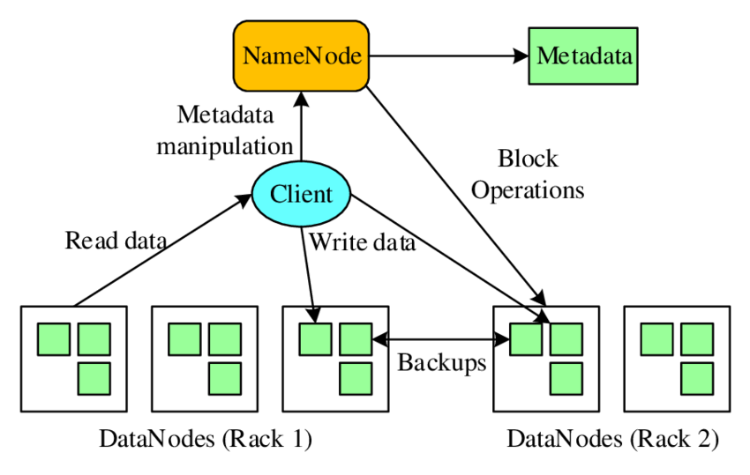

3. MapReduce Programming
Revisited from earlier section – but in Hadoop:
Structure:
- InputSplit: Divides the data for parallel processing.
- RecordReader: Converts InputSplit into key-value pairs.
- Mapper: Processes key-value pairs.
- Reducer: Aggregates output.
Execution Flow:
mathematica
Input Data → InputFormat → Mapper → Shuffle/Sort → Reducer → OutputFormat → Output
Example: Counting occurrences of a word across multiple documents.

4. YARN (Yet Another Resource Negotiator)
Purpose:
Decouples resource management and job scheduling from the MapReduce engine, enabling support for multiple data processing engines.
Key Components:
- ResourceManager (RM): Manages cluster resources.
- NodeManager (NM): Manages resources on individual nodes.
- ApplicationMaster (AM): Manages lifecycle of an application.
- Containers: Actual computation units.
Architecture:
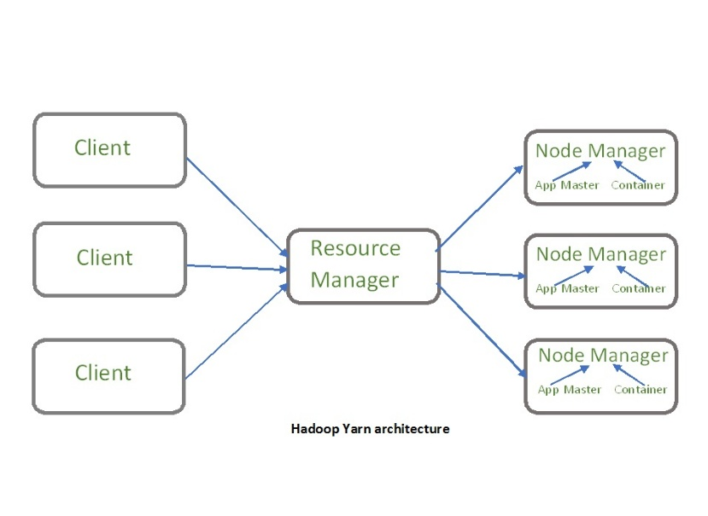

5. Hadoop Components
Core Components:
- HDFS
- MapReduce
- YARN
Related Tools:
Tool | Purpose
Hive | SQL-like query engine
Pig | High-level scripting
HBase | NoSQL database
Oozie | Workflow scheduler
Flume | Data ingestion from sources
Sqoop | Data transfer from RDBMS
Zookeeper | Coordination service

6. Programming Hadoop with Pig, R, and Spark (09 Programming Hadoop...)

Pig:
- Language: Pig Latin (dataflow language)
- Use Case: ETL tasks
- Execution: Converts scripts to MapReduce jobs
- Example:
pig
A = LOAD 'data.txt' AS (name:chararray, age:int);
B = FILTER A BY age > 25;

R with Hadoop:
- Integrate R’s statistical computing with Hadoop via RHadoop or RHIPE.
- Used for:
  - Data manipulation
  - Visualization
  - Machine learning

APACHE SPARK

3. Apache Spark
Apache Spark is an open-source, distributed computing system that provides fast and general-purpose cluster computing for big data processing, with support for in-memory processing.

1. Introduction to Spark
- Developed by: AMPLab at UC Berkeley
- Main Features:
  - In-memory data processing
  - Fault tolerance
  - High-level APIs in Python, Scala, Java, R
  - Supports SQL, streaming, ML, and graph processing
- Comparison with Hadoop MapReduce:
  - Spark is ~100x faster in-memory and ~10x faster on disk
  - Supports iterative algorithms and real-time processing

2. RDDs (Resilient Distributed Datasets)
Definition:
RDDs are Spark’s core abstraction — a fault-tolerant collection of elements that can be operated on in parallel.
Properties:
- Immutable
- Lazily evaluated
- Fault-tolerant via lineage graphs
- Partitioned across cluster nodes
Transformations vs. Actions:
Transformations | Actions
map(), filter() | collect(), count()
Example:
python
rdd = sc.textFile("data.txt")
words = rdd.flatMap(lambda line: line.split())
wordCounts = words.countByValue()

3. Spark Architecture
Components:
- Driver: Runs the main program and creates SparkContext
- Cluster Manager: (YARN/Mesos/Kubernetes/Standalone)
- Executors: Run tasks and return results
- Tasks: Units of work sent to executors
Architecture Flow:
- User submits application (Driver Program)
- Driver contacts Cluster Manager
- Cluster Manager launches Executors
- Tasks sent to Executors
- Results returned to Driver
Diagram:

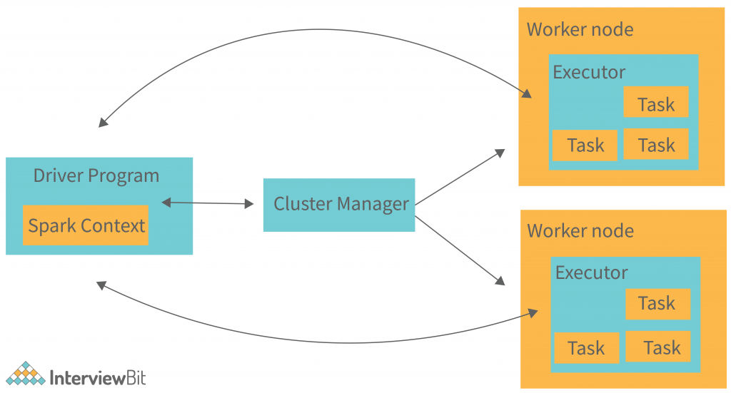
(Include driver program, cluster manager, executors, RDD flow, and task scheduling)

Performance Comparison of Hadoop and Spark
Aspect | Hadoop | Spark
Processing | Disk-based | In-memory
Speed | Slower due to disk I/O | Up to 100x faster (memory operations)
Programming | Java-based MapReduce (low-level) | APIs in Python, Scala, R, Java
Fault Tolerance | Data replication | RDD lineage tracking
Batch vs Real-time | Batch only | Batch + Streaming + ML
Machine Learning | External tools required (e.g., Mahout) | Built-in MLlib
Conclusion:
- Spark outperforms Hadoop for iterative algorithms and real-time data.
- Hadoop remains relevant for extremely large batch jobs and where memory is limited.

5. MLlib – Machine Learning in Spark (BigData_Spark_MlLib_new1.pdf)
MLlib is Spark’s scalable machine learning library.
Features:
- Classification: SVMs, logistic regression
- Regression: Linear regression
- Clustering: k-means
- Collaborative Filtering: ALS
- Dimensionality Reduction: PCA
ML Pipeline API:
- Similar to scikit-learn pipeline:
  - Transformer
  - Estimator
  - Pipeline
Example:
python
from pyspark.ml.classification import LogisticRegression
lr = LogisticRegression(featuresCol='features', labelCol='label')
model = lr.fit(trainingData)

6. Deep Learning with Spark (DeepLearn_Spark_Part1.pdf & Part2.pdf)
Deep Learning with Spark is typically achieved using libraries such as:
- BigDL (Intel)
- DL4J (DeepLearning4J)
- TensorFlowOnSpark
BigDL Example:
python
model = Sequential()
model.add(Linear(2, 2))
model.add(ReLU())
model.add(Linear(2, 1))
Benefits:
- Scalable training
- Distributed inference
- Integration with Spark DataFrames and pipelines
Use Case: Real-time image classification or time-series prediction over Spark.

NoSQL Databases

4. NoSQL Databases

🔹 Introduction to NoSQL
NoSQL = “Not only SQL” – non-relational, distributed, and horizontally scalable databases designed for unstructured or semi-structured data.

⚙️ Key Features:
- Schema-less data model
- High availability and scalability
- BASE properties (Basically Available, Soft state, Eventual consistency) vs. ACID in RDBMS
- Supports horizontal scaling (adding more servers)

🔹 Types of NoSQL Databases:
Type | Description | Examples
Key-Value Store | Key is mapped to a value | Redis, Riak
Document Store | JSON/XML/BSON documents | MongoDB, CouchDB
Column-Family | Column groups (like tables) | Cassandra, HBase
Graph Database | Nodes and relationships | Neo4j, Titan

🔹 HBase
Apache HBase is a distributed, column-oriented NoSQL database built on top of HDFS and modeled after Google’s Bigtable.

⚙️ Features:
- Ideal for sparse datasets
- Real-time read/write access
- Strong consistency
- Scalable horizontally

📊 Data Model:
- Tables → Rows → Column Families → Columns → Cells
- Each cell is versioned by timestamp

🧠 Use Case:
- Time-series data, sensor data, logs

🔄 Architecture
- HMaster: Manages RegionServers
- RegionServers: Handle read/write requests
- ZooKeeper: Coordinates distributed nodes

🔧 Example:
bash
create 'student', 'info'
put 'student', '1', 'info:name', 'John'

🔹 Hive
Apache Hive is a data warehouse system built on Hadoop that provides SQL-like querying interface (HiveQL) for analyzing large datasets.

⚙️ Key Concepts:
- Converts queries into MapReduce, Tez, or Spark jobs
- Supports structured data
- Used for batch processing and analytics

📦 Hive Components:
- Metastore: Stores metadata (schemas, tables)
- Driver: Manages query execution
- Compiler: Converts HiveQL to DAG/MapReduce
- Execution Engine: Executes jobs on Hadoop

🗃️ Data Model:
- Tables, Partitions, Buckets
- Supports ORC, Parquet, Avro formats

💡 Example HiveQL:
sql
CREATE TABLE emp(id INT, name STRING);
LOAD DATA INPATH 'emp.csv' INTO TABLE emp;
SELECT * FROM emp WHERE id > 100;

🧠 Use Case:
- Data warehousing
- Business intelligence on big data

🔹 Cassandra
Apache Cassandra is a highly scalable, distributed NoSQL database designed for handling large amounts of data across many servers.

⚙️ Features:
- Peer-to-peer architecture (no master/slave)
- Linear scalability
- Fault tolerance
- Tunable consistency

💡 Data Model:
- Similar to HBase: Table → Rows → Columns
- Uses CQL (Cassandra Query Language) similar to SQL

🧠 Use Cases:
- IoT data ingestion
- Recommendation engines
- Social media apps (high availability)

🔄 Architecture:
- Nodes: Store data
- Clusters: Group of nodes
- Gossip Protocol: Communication among nodes
- Replication Factor: Copies of data on different nodes

🧪 Example CQL:
sql
CREATE KEYSPACE test WITH replication = {'class':'SimpleStrategy', 'replication_factor':3};
CREATE TABLE test.users(id UUID PRIMARY KEY, name text);
INSERT INTO test.users(id, name) VALUES (uuid(), 'Alice');

📊 Comparison Table
Feature | HBase | Hive | Cassandra
Data Model | Column-oriented | Table-based (SQL) | Column-family
Query Language | HBase shell / API | HiveQL | CQL
Real-time Access | Yes | No (batch only) | Yes
Best For | Random read/write | Analytics | High availability
Fault Tolerance | High | High | Very High

Graph Processing in Big Data

5. Graph Processing in Big Data

🔹 Introduction to Graph Databases
A Graph Database is a type of NoSQL database designed to store and query data modeled as graphs. It uses nodes, edges, and properties instead of rows and columns.

🔗 Basic Concepts:
- Node: Entity (e.g., Person, Product)
- Edge: Relationship between nodes (e.g., FRIENDS_WITH)
- Property: Metadata (e.g., name, age)

✅ Benefits:
- Efficient for traversals (e.g., friends-of-friends)
- Ideal for highly connected data
- Schema-flexible

🔍 Use Cases:
- Social Networks
- Fraud Detection
- Recommendation Systems
- Network Routing

📌 Example Graph Model:
scss
(Alice) -[FRIENDS_WITH]-> (Bob)

🧪 Examples of Graph DBs:
- Neo4j
- Titan
- OrientDB
- ArangoDB

🔹 Apache Giraph
Apache Giraph is an iterative graph processing system built for large-scale graphs. It’s built on Apache Hadoop MapReduce and inspired by Google's Pregel.

⚙️ Features:
- Suitable for batch processing on graphs
- Uses a vertex-centric model (think from the perspective of a vertex)
- Scales to billions of edges

🧠 Programming Model:
- Supersteps: Computation is done in steps
- Message Passing: Vertices exchange messages during supersteps
- Halt: Vertices can vote to halt when computation is complete

🔄 Architecture:
- Runs on Hadoop cluster
- Uses master-worker model
- Each worker processes a partition of the graph

🔧 Example Use:
- PageRank
- Connected Components
- Shortest Path

🔹 Pregel and Its Variants
Pregel is Google’s system for large-scale graph processing.

📚 Core Ideas:
- Vertex-Centric Computation: Each node processes its state based on messages from neighbors
- Bulk Synchronous Parallel (BSP): Computation proceeds in synchronized steps
- Message Passing: Vertices send messages to each other in supersteps

🔄 Execution:
- Vertices receive messages
- Perform computation
- Send new messages
- Vote to halt (inactive until new message)

✨ Variants:
Variant | Description
Pregel+ | Optimized for better memory and performance
Blogel | Block-centric parallel processing
GraphX | Apache Spark library for graphs

🔹 Spark GraphX
GraphX is the graph computation engine in Apache Spark, combining graph and table computation.

🧠 Graph Representation:
- Based on RDDs (Resilient Distributed Datasets)
- Graph = (Vertices RDD, Edges RDD)

📦 GraphX Features:
- Supports ETL, querying, and graph analytics
- Native operators: subgraph, mapVertices, joinVertices, etc.
- Built-in algorithms: PageRank, Connected Components, Triangle Counting

🔁 Architecture:
- Part of the Spark Core
- Supports integration with MLlib

🔧 Sample Code:
scala
val users = sc.parallelize(Seq((1L, "Alice"), (2L, "Bob")))
val relationships = sc.parallelize(Seq(Edge(1L, 2L, "follows")))
val graph = Graph(users, relationships)
graph.vertices.collect()

🧠 Use Cases:
- Social graph analysis
- Network topologies
- Fraud ring detection

🔹 Titan Graph DB
Titan is a distributed, scalable graph database optimized for storing and querying massive graphs across a cluster.

⚙️ Features:
- Supports thousands of concurrent users
- Supports ACID transactions
- Integrates with Apache Cassandra, HBase, or BerkeleyDB
- Compatible with Gremlin query language (from TinkerPop)

🔍 Characteristics:
- Schema-optional
- Indexing support
- Scalable write throughput

🧠 Use Cases:
- Knowledge graphs
- Complex recommendations
- Semantic web

⚙️ Architecture Diagram:

📊 Summary Table
Tool | Type | Based On | Use Case | Programming Model
Neo4j/Titan | Graph DB | Custom | Querying complex relationships | Gremlin/Cypher
Apache Giraph | Graph engine | Hadoop MapReduce | Graph batch processing | Vertex-centric
Pregel | Graph engine | Internal to Google | Large-scale distributed graphs | Bulk Synchronous Parallel
GraphX | Spark Lib | Spark + RDD | Analytics + Graph Processing | Functional (RDDs + graphs)

6. Real-Time Data Streaming

🔹 Apache Kafka
Apache Kafka is a distributed streaming platform developed by LinkedIn and later open-sourced through the Apache Software Foundation.

✅ What Kafka Does
- Publishes and subscribes to streams of records
- Stores streams of records in a fault-tolerant manner
- Processes streams in real-time

🔁 Kafka Architecture

📦 Core Components
Component | Description
Producer | Sends data (messages) to Kafka topics
Consumer | Reads data from topics
Broker | Kafka server, stores and serves messages
Topic | Named stream of records (like a table)
Partition | Kafka topic is split into partitions for scalability
ZooKeeper | Manages brokers, leader election, metadata

🔄 Data Flow in Kafka
- Producers publish records to a topic.
- Kafka brokers store records.
- Consumers read records from the topic in real-time or later.

📌 Use Cases
- Log aggregation
- Real-time analytics
- Messaging queues
- Website activity tracking
- Fraud detection

7. Machine Learning on Big Data

🔹 Apache Mahout
Apache Mahout is a machine learning library designed to scale on big data platforms like Hadoop.

🎯 Key Goals
- Create scalable ML algorithms
- Enable easy use with Apache Hadoop (MapReduce) and Spark
- Provide distributed linear algebra framework

🧠 Supported ML Algorithms
Category | Algorithms
Clustering | k-Means, Fuzzy k-Means, Spectral
Classification | Naive Bayes, Logistic Regression
Recommendation | Collaborative filtering, Matrix Factorization

⚙️ How Mahout Works
- Uses Hadoop MapReduce (older versions)
- Now uses Apache Spark + H2O backend
- Algorithms operate on distributed datasets

📌 Example Use Cases
- Product recommendation
- Spam detection
- Sentiment analysis

🛠️ Sample Command (K-Means Example):
bash
mahout kmeans -i input-vectors -c clusters -o output -dm euclidean -x 10 -k 4 -cl

🔹 MLlib (Spark's ML Library)
MLlib is Apache Spark’s machine learning library for scalable ML algorithms.

🔧 MLlib Features
- Built on top of Spark Core
- Supports DataFrames and RDDs
- Compatible with Spark SQL and GraphX

📚 Algorithms in MLlib
Task | Algorithms
Classification | Logistic Regression, SVM, Decision Tree
Regression | Linear Regression, Ridge, Lasso
Clustering | K-Means, Gaussian Mixture
Recommendation | ALS (Collaborative Filtering)
Dimensionality Reduction | PCA, SVD
Feature Extraction | TF-IDF, Word2Vec, HashingTF

🧪 Pipeline API
MLlib provides a high-level pipeline API similar to scikit-learn:
- Transformers – apply transformations
- Estimators – learn from data
- Pipeline – sequence of stages

🧠 Sample Code (in PySpark):
python
from pyspark.ml.classification import LogisticRegression
from pyspark.ml.feature import Tokenizer
from pyspark.ml import Pipeline

tokenizer = Tokenizer(inputCol="text", outputCol="words")
lr = LogisticRegression(maxIter=10)
pipeline = Pipeline(stages=[tokenizer, lr])
model = pipeline.fit(trainingData)

📌 Use Cases:
- Predictive analytics
- Customer segmentation
- Real-time fraud detection
- Churn prediction

✅ Summary
Tool | Description | Suitable For | Built On
Kafka | Real-time event streaming platform | Log streaming, activity tracking | JVM, Zookeeper
Mahout | Scalable machine learning algorithms | Batch ML, recommendation systems | Hadoop, Spark
MLlib | Spark-based ML library | Large-scale ML, streaming ML | Spark

